Step 1. INSTALLED **CHOCOLATEY**

Insalled chocolatey with the command in powershell 5(old default in windows ~ light blue icon) with the command:

**Set-ExecutionPolicy Bypass -Scope Process -Force; [System.Net.ServicePointManager]::SecurityProtocol = [System.Net.ServicePointManager]::SecurityProtocol -bor 3072; iex ((New-Object System.Net.WebClient).DownloadString('https://community.chocolatey.org/install.ps1'))**

and checked the version with the provided command:

**choco –version**

the version is 2.2.2

***Now, close & re-open the PowerShell 5 to work efficiently (like restarting the powerhsell)*******

**Step 2. INSTALL MODERNSHELL / POWERSHELL** 7 / POWERSHELL CORE**: bcoz we will be working with powershell 7 not powershell 5**

Installing Modern Shell (PowerShell 7.x or PowerShell Core ~ navy blue icon): with the command:

We open the old default PowerShell 5(light blue icon, run as admin) to install powershell 7 and run the command :

**choco install powershell-core microsoft-windows-terminal git vscode vscode-powershell vagrant packer virtualbox**

Now, I opened the ‘terminal’ from the start button in windows(not run as admin just double click,bcoz we are not installing we are going to use it) and ran the command **ssh -V** in PowerShell 7~ navy blue icon to check the ssh version

Here is the screenshot:

And the powershell version: **pwsh –version**

Installing **Modern terminal:**

In windows 11 it comes default. so just open the terminal and go to about and take a screenshot of the

windows terminal version.

checking git version from the ‘terminal’ (powershell 7): using the command git –version

Step 3:

**Install/ configure git client** for version control:

I ran these 2 commands in ‘terminal’ (powershell 7):

**git config --global user.name "Naga Satya Shilpa"**

**git config --global user.email “nannadevara@hawk.iit.edu”**

Here is the screenshot:

**Install virtual box**:

I already installed virtual box so go to virtual box and go to help , aout and take the screenshot:

Or

From the ‘terminal’(powershell 7) with the command:

vboxmanage --version

Vagrant : next class

Packario : next class

Oh my git tutorial **(GAME**) and complete and take sc’s: (done with game few sections and posted in the repo, not pasted those game sc’s here coz nothing to learn in that game )

**GIT TUTORIAL: we configured user name and email previously in the above steps)**

Now, Lets **create key pair for authentication**:

Open the ‘terminal’ in that open powershell 7(just like the previous)

**ssh-keygen -t ed25519**

Then match with the path and enter your wish file name as follows: copy the above path first and then extend the path with whatever file name suitable for this subject: (path_github_itmd521_key)

C:\Users\satya/.ssh/id_ed25519_github_itmd521_key

.pub is the public key, identification is the private key saved in those paths.

Now display the public key:

cat C:\Users\satya/.ssh/id_ed25519_github_itmd521_key.pub

the public key displayed :

ssh-ed25519 AAAAC3NzaC1lZDI1NTE5AAAAIPJkII+vsQKO+hpQL0zLYG8Ki2ADj1oukfsjTpwCtsFX satya@LAPTOP-LISN0TA4

and then added this public key in github -setting – ssh gpg keys – add ssh key – paste this key – add appropriate title and save. (did it)

Now **lets create config file**:

Every user have .ssh directory under home directory when you type ls In your home directory..you will see ssh directoryif you did ssh keygen in the prev step

What is home directory? When you open ‘terminal’ – powershell 7 – whatever shows initially, it is our home directory.

For instance mine is : C:\Users\satya>

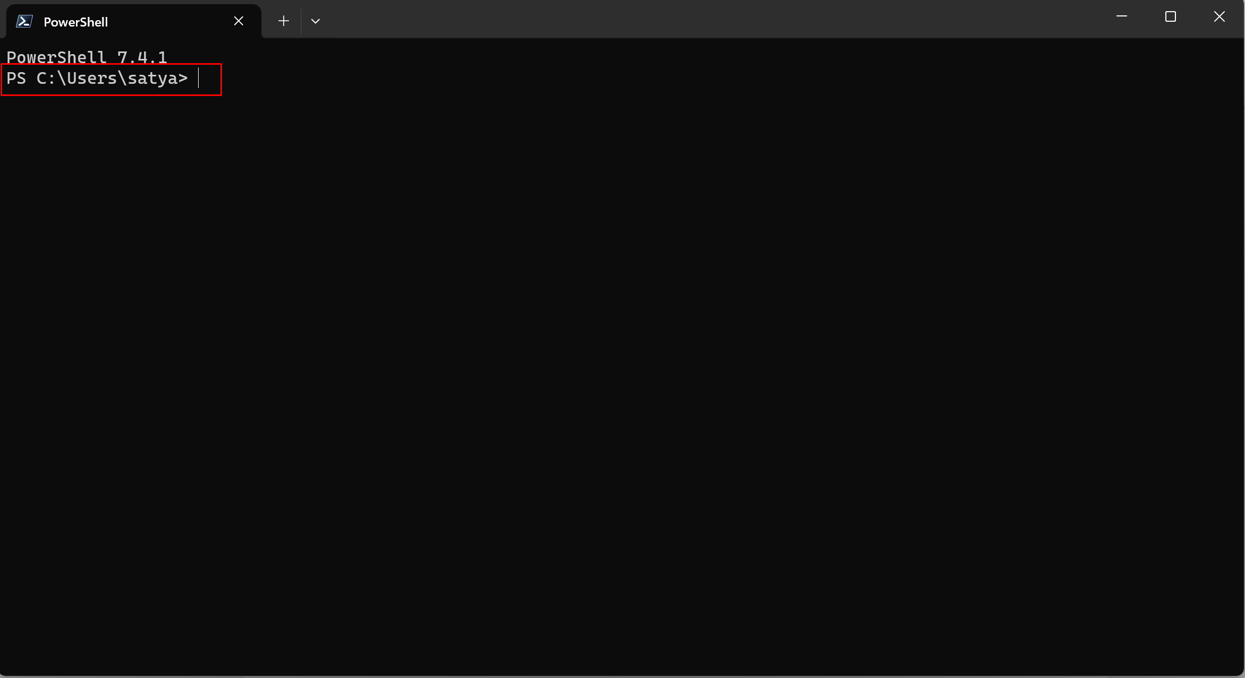

To check whether .ssh directory is there by or not, type ls in home directory (satya directory) (in terminal powershell 7)and check like this.

This ssh directory only shows up only if you did that ssh keygen command earlier. Or else it wont show up. That command forces you to create this ssh directory.

Now let go to ‘terminal’ – powershell 7 (we already in it)

Lets go to ssh directoty by using cd command:

cd .ssh

Now we are in ss directory

Type ls

Professor will have a lot of things , but for us only these 2 will be there.

These are our pub and private keys

Now **create a file called config**: (prof already have config file so he just did cat config, to show us how it looks like. So when he did, he got a screen saying that when we connect to host ( github.com) use these values. user is the github ID not the repository(whatever ID we submitted to professor), Identity file is the path to the private key (look at the ssh keygen screenshot to get this path) , so that when we connect to github , it will present the key to authenticate, and authenticate us without we typing any passwords ) A screen shot of a computer

But for us first we need to create config file:

If we have vs code, in terminal - powershell 7 ( now we are in ssh directory) type :

code config (hit enter)

it will open us the vs code. With config file. Now edit there.

# Comments are allowed by using the # sign

# This line tells SSH to use these values whenever a connection is made to github.com

Host github.com

# This is the username or ID you created for GitHub

User jhajek

Hostname github.com

# This command tells SSH which Private key to use when making an SSH

# connection to GitHub

IdentityFile ~/.ssh/id_ed25519_340_github_key

**So based on above code, My config file content/code is here:**

Host github.com

User Shilpa206

Hostname github.com

IdentityFile C:/Users/satya/.ssh/id_ed25519_github_itmd521_key

Now lets clone it :

Open’terminal’ – powershell 7 -go to documents directory by

cd Documents

Now we are in Documents directory, Make a directory for ‘itmd-521’ in this documents directory with the following command:

mkdir itmd-521

Now go to itmd 521 directory by

cd itmd521

We are in itmd-521 folder, so now we are ready to connect to github to clone

The 1st thing we are gonna do is double check our config file is set up and keys are set up correctly with the command:

ssh [git@github.com](mailto:git@github.com)

Type yes to fingerprint (as this is our first time connection it will prompt us to do this, it was like hey you never connected to this server, do you want to connect? So type yes) ignore PTY and hit enter. We will ge this Hi shilpa206 output

SUCEESS!

Next thing is clone now:

Go back to github private repo (nannadevara repo)

We need to get the url so we can clone this repo from remote github and make a local copy.

So go to the nannadevara private repo – code – ssh- you see the url – copy it – go to terminal powershell 7 (the above image we are already in) (yoi can do it itmd-521 folder of documents folder, wherever you want but remember it. But im doing in th itmd-521 folder only. So lets clone now with the command:

git clone paste the url : this means :

git clone [git@github.com:illinoistech-itm/nannadevara.git](mailto:git@github.com:illinoistech-itm/nannadevara.git)

hit enter

SUCCESS! in the future , we wont clone again, We will clone only once, we will only pull (but we can always clone it again if we want to)

so what does this do ? it’s a copy in your local computer, not downloading a zip file or something like that

So now we can do the readme document(intro) And then we will do the templates screenshots with all our screenshots.

So we do some sample pushing and then we will come back and do this readme.

Go to vs code, close the confg file and open folder , (my nannadevara folder, select that folder and open it)

Boom. In vs code my nannadevara itmd 521 folder will open.(entire repo will be open) ignore the gitignore file and open that readme.(where we need to do our intro part)

Copy that h1 and h2 code in the prof given file (intro part) and paste in this readme.

Do all the edit(fill my details , introduction, images everything) if forgot ~ watch video – git tutorial part 1 from 1:04:00

C:\Users\satya\Documents\itmd-521>

*********** ote that this intro readme is done only once , we will not do this intro readme from the next week)************

**Tooling assignment part 2: tutorial video part 2: adding screenshots of our installations, showing versions:**

In each class we will get a readme file attached where we need to upload the screenshots of our tooling assignment.

We need to download this file and put into the local repository.

Download it. it will be in our downloads.

Go to vs code and in the nannadevara folder , add a folder name called ‘itmd-521’, and add sub- folder under this itmd-521 called ‘tooling-assignment’. (all lower case and dash in the middle)

Now drag this readme.md (pasting screenshots file) In to the tooling-assignment folder (subfolder of itmd-521). Don’t rename the readme file bcoz github will auto render the markdown in readme. If we rename, it wont render and we wont be able to turn in anything.

Also make another folder called ‘images’ in the tooling assignment

(NOTE: not the images folder for the intro readme.the intro readme images folder is outside the itmd-521 folder)

So all the version screenshots, dump into that images folder from snippet or lightshot in your local computer, (remember name screenshots with command names bcoz easy to read and identify)

whenever you add screenshots in images folder in local, come to vs code and you can see changes has been done to images folder

so go to readme file an markdown the screenshots with syntax(tutorial video 2, 7:57) make sure the images file path is matching

go to preview to check

so markdown like 2 images an do the commit for every 2 images,(best practice)

go to GitHub and refresh and see the changes had happened or not.

So once you are done with intro readme and screenshots readme….DONE

Go to GitHub and copy the nannadevara url and submit in to BB